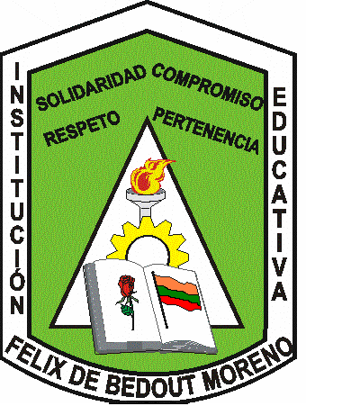
INSTITUCIÓN EDUCATIVA FÉLIX DE BEDOUT MORENO

“Educamos en el ser y el conocer con respeto y compromiso”

CLASS GUIDE / NINTH GRADE / MOVIE TASK

TUESDAY, MARCH 18TH
MOVIE TASK “BRAVE”

- WHAT’S THE TOPIC? (ONE WORD).
- WHAT’S THE MAIN IDEA ABOUT THE MOVIE?
- WRITE A SUMMARY IN A PARAGRAPH (IN SIMPLE PAST TENSE).
- ENNOUNCE THE MAIN CHARACTERS.
- ENNOUNCE THE SECONDARY ONES.
- WHAT WAS YOUR FAVORITE ONE? MAKE A DETAILED DESCRIPTION.
- WHO WAS THE GUILTY ONE ABOUT THAT CHAOS?
- WHAT DID THE PROBLEMIC SITUATION GET ORIGIN?
- WHERE WAS THE MOVIE CARRIED OUT?
- WHY DID MELIDA DO WHAT SHE DID?
- WHAT WERE THE RULES THAT GOVERNED WOMEN IN THAT EPOCH?
- HOW DID THE MOVIE END?
- WHAT’S THE MORAL FOR YOU?
- WHAT DID YOU THINK ABOUT THE MOVIE?
- WHY WAS “BRAVE” THE TITLE?
- HOW DO YOU SEE WOMEN’S ROLE NOWADAYS?
- HOW MANY TRIBUS WERE PRESENTED DURING THE POSSIBLE ENGAGEMENT?
- MAKE AN ACROSTIC USING THE WORD BRAVE.
- MAKE A POSTER ABOUT IT.
- PREPARE A SHORT SPEECH ABOUT THE MOVIE (USE THE SIMPLE PAST TENSE).

